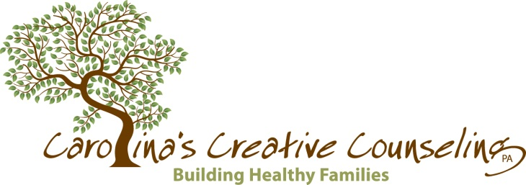

**C3 SHOP**

Name: _____________________________________________ Date: _________________________

Phone: _____________________________________________

Email:______________________________________________

**Women’s Fleece Jacket**

Price: $35

Color Size (1-4) Quantity

* Solid Black or Molten Lead & Black _____ _____
* Bracken Fern & Navy _____ _____
* Martha’s Vineyard _____ _____
* Ruby Hill & Cherry _____ _____

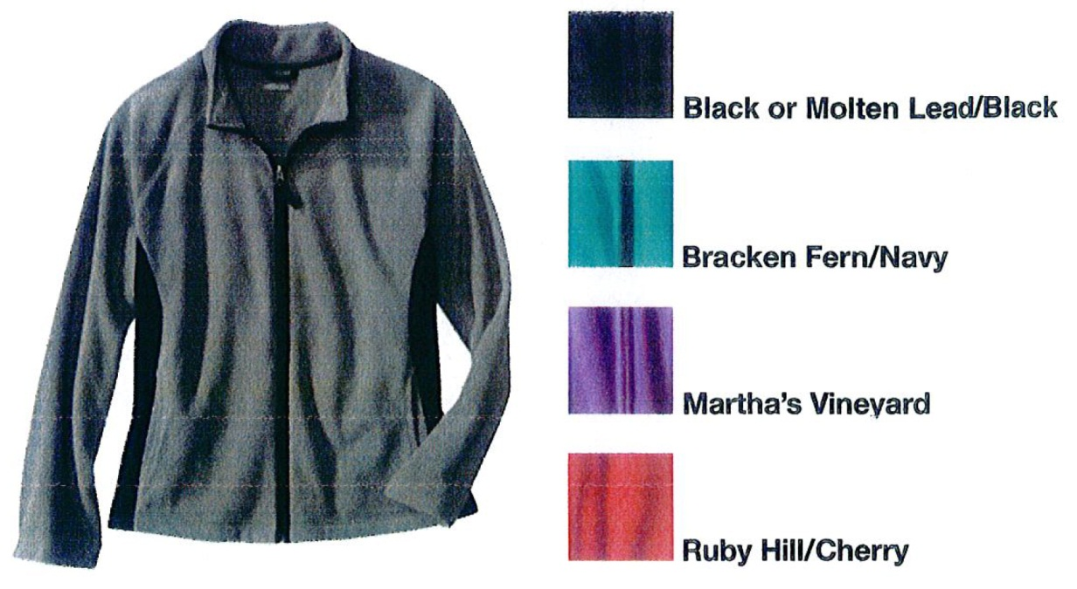

Color Size (XS-XXL) Quantity

* Hyacinth Violet _____ _____
* Jazzy Turquoise & Night Blue _____ _____
* Molten Lead & Black _____ _____
* Ruby Hill & Bing Cherry _____ _____

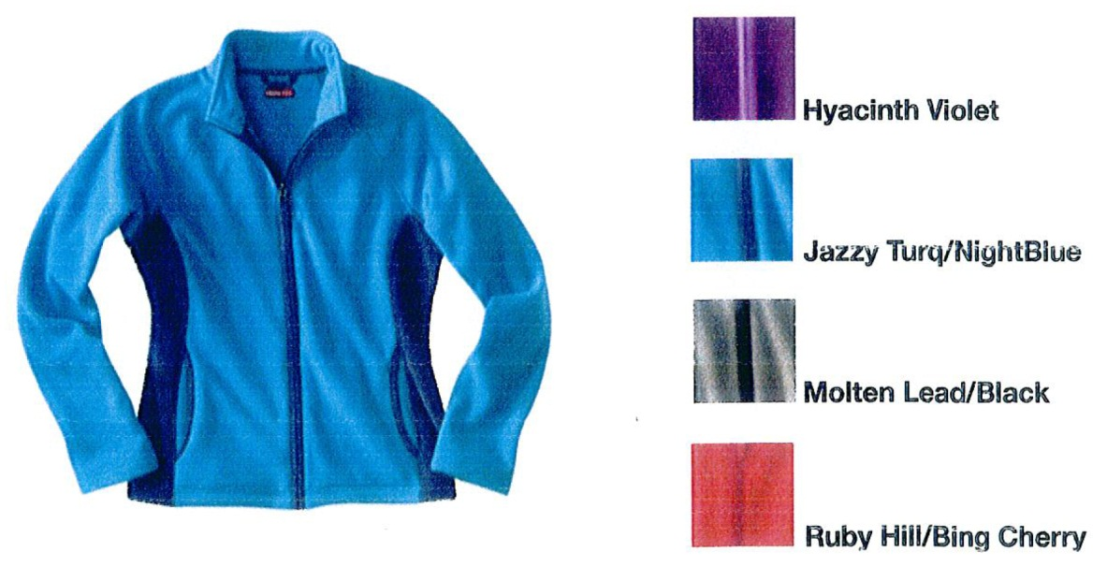

**Men’s Fleece Jacket**

Price: $35

Color Size (XXL, XXXL) Quantity

* Gray Stone _____ _____
* Blue Corsica _____ _____
* Coral Dilemma _____ _____
* Coffee Grounds _____ _____
* Black Jack _____ _____

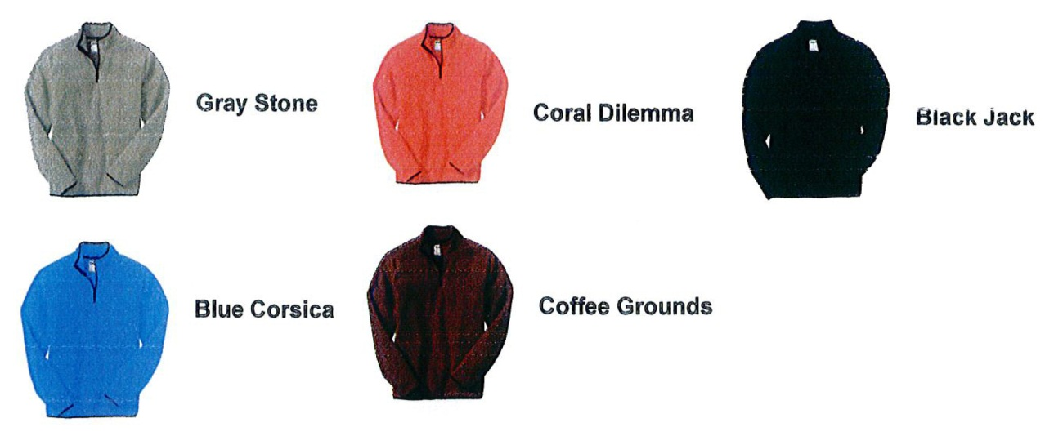

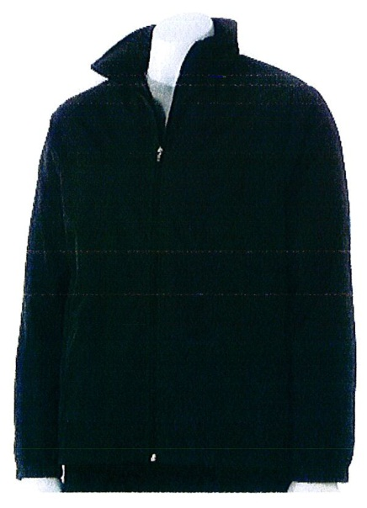**Men’s Tek Gear Windwear Jacket**

Price: $35

Color Size (XLT, 2XLT, 3XLT, 2XB, 3XB, 4XB) Quantity

* Black _____ _____

Color of C3 logo

* Yellow
* Red
* Green
* Light Blue

**Stadium cups** Quantity

Price: $2.50 _____

**Pen** Quantity

Price: $3 _____

**Ruler with pencil & pencil sharpener** Quantity

$2.50 _____

**Total: $__________**

Email form to cathy@c3families.com or fax to 704.332.1801

Mail or hand-deliver a check written to *Carolina’s Creative Counseling, PA* to:

Carolina’s Creative Counseling, PA

Attn: Cathy Harris

4415 Monroe Road, Suite 100

Charlotte, NC 28205